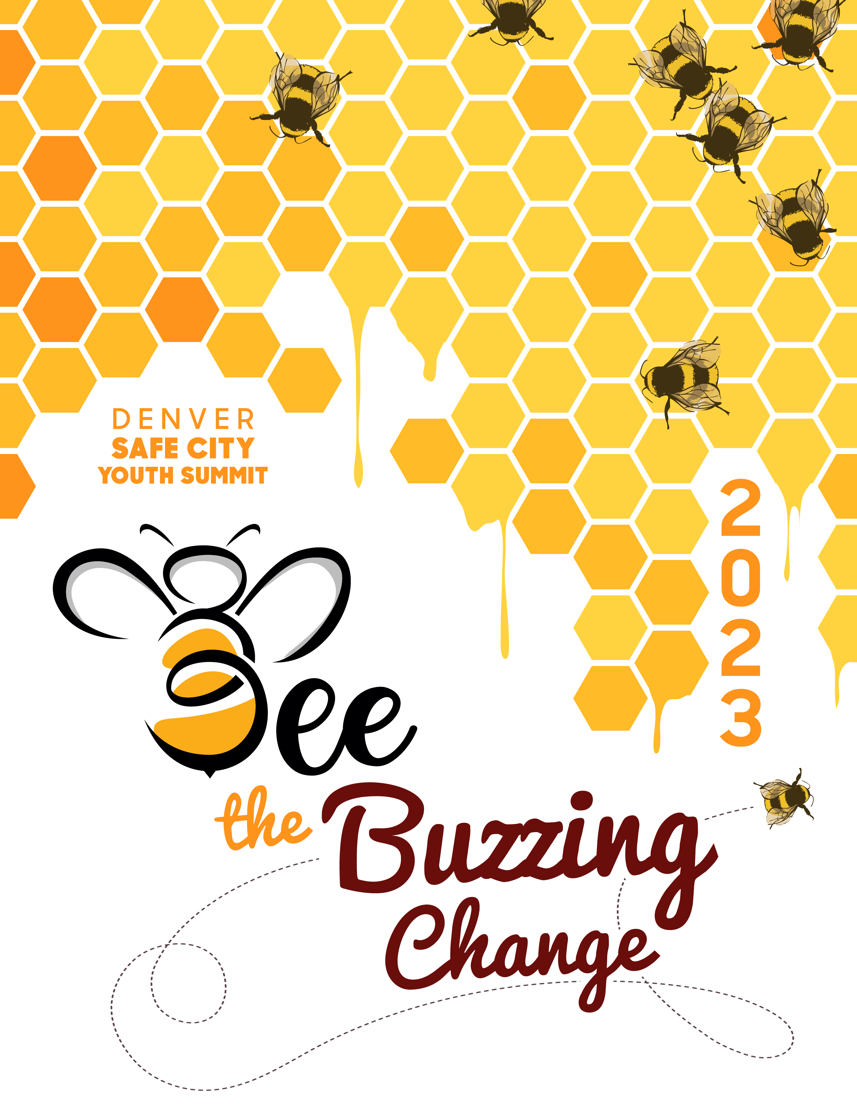

The Public Safety Youth Leadership Team (PSYLT) is excited to announce they will give away their 9th “College Scholarship in Memory of Walt Beckert” in the amount of $1000. PSYLT will also be giving away one additional $250 college scholarships. The team has fundraised to make this happen. The PSYLT will award a youth from the Denver Metro Area to encourage & support secondary education! Please fill out the application and complete the requirements by February 10, 2023 (Any application turned in after the deadline will not be considered).

Requirements:
- Must be enrolled in a Denver Public School
- Ages of 13-18
- Must be registered and attend the day of the Youth Summit
  - March 24, 2023
- Complete application and turn in by the deadline
- If there is not enough space on the application form attachment will be accepted
- Be able to provide a Social Security Number if selected for scholarship

Selection:
- Application will be reviewed by a youth panel based on:
  - Application
  - Written/ Creative Art Form
  - Applicant selected for scholarship will be notified by Feb 14, 2023
  - Selected Applicant must attend the Youth Summit to receive scholarship

Public Safety Youth Leadership Team
Attn: Youth Summit
303 W. Colfax # 1000
Denver, CO 80204
Phone: 720-913-4621
Fax: 720-913-4621
Email: Neveah.Casanova@denvergov.org

Scholarship Application

PERSONAL: The following questions on the page do not affect whether you will or will not receive this scholarship except for SSN question.

Name: ____________________________Home Phone: ___________________Cell #:___________________
Print Name

Address: _________________________________________________________________________________
(Street) (City) (State) (Zip Code)

DOB: ______________________________ E-mail Address: _______________________________________
(MM/DD/YY)

Upon Request will you be able to provide a Social Security Number (SSN)? YES____NO_____
(Applicant chosen for scholarship must have SSN or will not be eligible)

Race/ Ethnicity:
□ White/Caucasian □ Black/African American
□ Asian or Pacific Islander □ Spanish, Hispanic or Latino (a)
□ American Indian or Alaskan Native □ Other_____________________

School Attending: __________________________________________________________________________

Grade: _________; If senior what college are you planning to attend?_______________________________

College(s): 1st choice: ___________________________2nd choice:___________________________________

Interested Major(s): ________________________________________________________________________

Future Education Plans:
______________________________________________________________________________________________________________________________________________________________________________________________________________________________________________________________________________
__________________________________________________________________________________________
__________________________________________________________________________________________

LEADERSHIP & VOLUNTEER EXPERIENCE: Please list specific leadership experience and volunteer responsibilities in your community, school, or other organizations.
____________________________________________________________________________________________________________________________________________________________________________________
____________________________________________________________________________________________________________________________________________________________________________________

YOUTH SUMMIT:
Have you ever attended a Safe City Youth Summit? YES___ NO___
If yes, when did you attend: ___________________________________________________________________
What do you expect to learn from the Youth Summit? ______________________________________________
__________________________________________________________________________________________

Scholarship Application

How did you hear about The Public Safety Youth Leadership Team/Youth Summit? ______________________
__________________________________________________________________________________________

PERSONAL STATEMENT:
In the following space please write a short statement on how this scholarship can help you, we want to know that we are giving this scholarship to someone who needs it. It’s important to answer two big questions; Why do want this scholarship? And how can it help you in your plans to further your education? (50 to 300 Words)
____________________________________________________________________________________________________________________________________________________________________________________________________________________________________________________________________________________________________________________________________________________________________________________________________________________________________________________________________________________________________________________________________________________________
________________________________________________________________________________________________________________________________________________________________________________________________________________________________________________________________________________________________________________________________________________________________________

EXPRESS YOURSELF:
You are required to submit an essay or piece of artwork to be eligible to receive this scholarship.
Remember BE CREATIVE, USE YOUR IMAGINATION!! Submit artwork with your application in person or via email using pictures or a document.

Show us who you are!
Here are some ideas for your art:
- Poem
- Painting
What does it mean to strive for new beginnings?
- Song/Rap
- Scripts
- Video
- Sculpture
We look forward to seeing what you do!!
- Drawing

Whatever inspires you!

I, attest that the information provided in this application is true and correct and agree that any untruthful or misleading answers, or omission of fact, may result in rejection of this application.

Signature: ______________________________________ Date: ___________________________________
This page is space for you to use for your creative art piece. Get creative with our 2023 Safe City Youth Summit Logo. Show us what you can do. YOU DO NOT HAVE TO USE THIS PAGE UNLESS THIS IS THE ART FORM YOU CHOOSE. Every other artform and essay is still available.

